Regulations:
A18

H.T No

Sreenidhi Institute of Science and Technology
(An Autonomous Institution)
Code No: 7AC02 Date: 11-Jan-2020 (FN)

B.Tech I-Year I-Semester External Examination, Jan-2020 (Regular)
NETWORK ANALYSIS (ECE)

Time: 3 Hours Max.Marks:70

Note: a) No additional answer sheets will be provided.
b) All sub-parts of a question must be answered at one place only, otherwise it will not be valued.
c) Missing data can be assumed suitably.

Part - A Max.Marks:20

Answer all QUESTIONS.

1. | Describe source transformation technique. | [2M]
2. | Explain basic tie-set matrices for planar networks. | [2M]
3. | When a conductor is moved inside a uniform magnetic field? | [2M]
4. | Write the merits and demerits of Parallel and Series circuits. | [2M]
5. | What is Resonance? Explain. | [2M]
6. | State the Maximum power transfer theorem. | [2M]
7. | State Kirchhoff’s Laws. | [2M]
8. | Explain faraday’s laws of electromagnetic induction. | [2M]
9. | List out the applications and limitations of Millman’s theorem. | [2M]
10. | What is the voltage across 10Ω resistor for the circuit shown in the below figure?  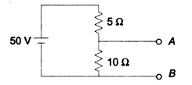 | [2M]
Part – B Max.Marks:50
ANSWER ANY FIVE QUESTIONS. EACH QUESTION CARRIES 10 MARKS.

11. | a) | Find the current delivered by the source for the network shown in the below figure using network reductions technique.  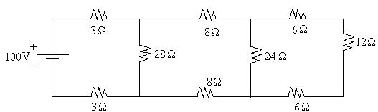 | [7M]
 | b) | Distinguish between Independent and dependent sources. | [3M]
12. | a) | Explain duality in electrical engineering. State the steps followed in finding the dual of a network. | [4M]
 | b) | Determine the voltages at each node by using nodal analysis for the circuit shown in the figure.  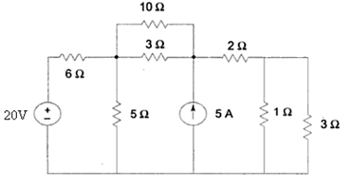 | [6M]
13. | a) | The air gap in a magnetic circuit is 1.5 mm long and 2500 mm² in cross section. Calculate:  (i) the reluctance of the air gap.  (ii) the mmf to send a flux of 800µWb across the air gap. | [5M]
 | b) | Distinguish between electric and magnetic circuits. | [5M]
14. | a) | A series circuit consisting of a 10Ω resistor, a 100μF capacitance and 10 mH inductance is driven by a 50Hz AC voltage source of maximum value 100V. Calculate the equivalent impedance, current in the circuit, the power factor. | [5M]
 | b) | Explain Steady state analysis of R, L and C (in different combination) with sinusoidal excitation. | [5M]
15. | a) | Derive the expression for bandwidth in a series R-L circuit in terms of Q-factor and resonance frequency. | [5M]
 | b) | A series RLC circuit with R=100, L = 0.5H and C=40μF has an applied voltage of 100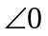with variable frequency. Calculate the resonance frequency, current at resonance voltage across RLC. | [5M]
16. | a) | State and explain Thevenin’s theorem with an example. | [5M]
 | b) | State and explain Compensation theorem with an example. | [5M]
17. | a) | What is meant by super node and super mesh? | [4M]
 | b) | Write the advantages and disadvantages of tie-set matrix. | [3M]
 | c) | What is mutual inductance? Explain. | [3M]
18. | a) | Define the terms reactance and phase angle. | [4M]
 | b) | Write the differences between series and parallel resonance circuits. | [3M]
 | c) | Write the applications of superposition theorem. | [3M]

-- 00 -- 00 –

